2019
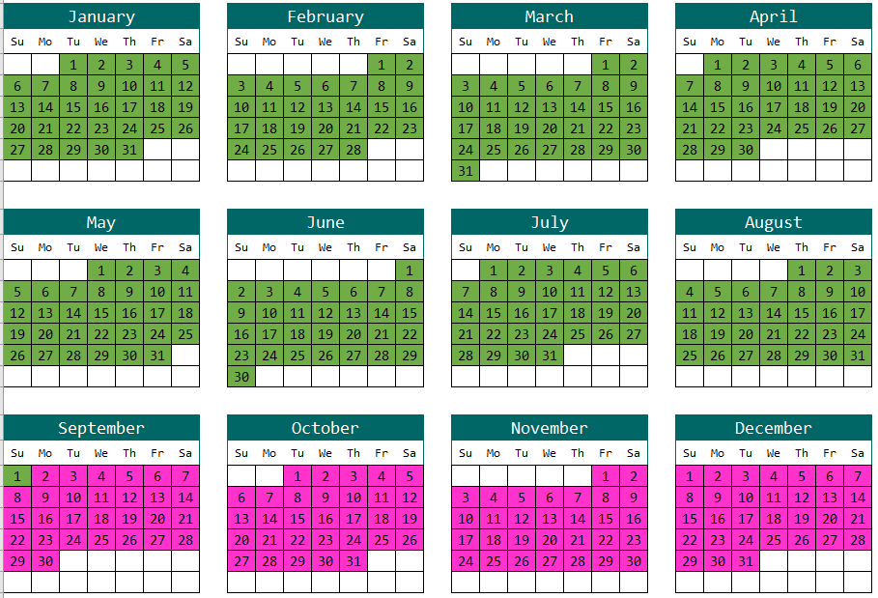
2020
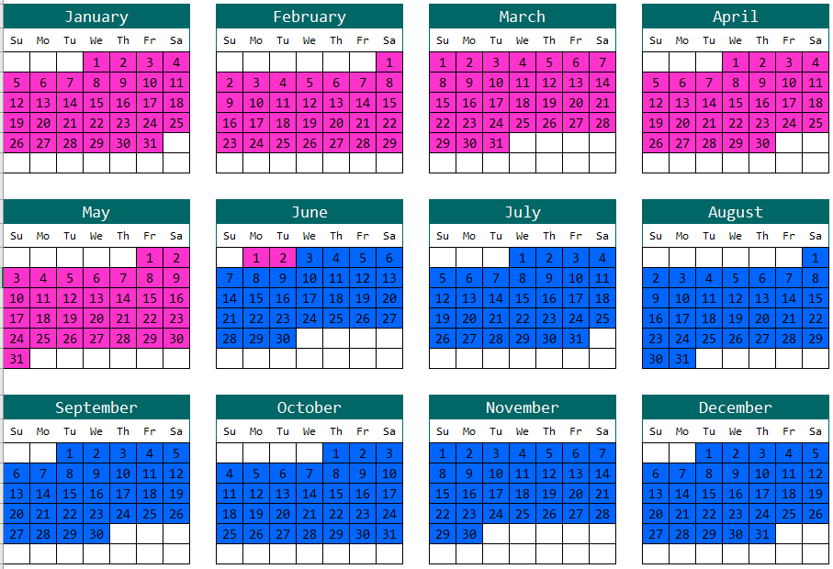
2021
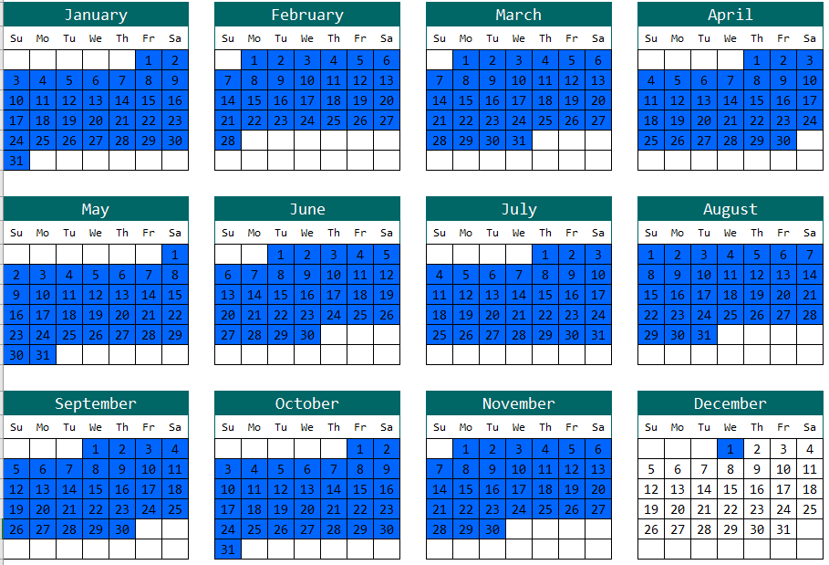
Green: If the child's birthday is green, they are eligible for Kindergarten (K)
Pink: If the child's birthday is pink, they are eligible for Transitional Kindergarten (TK)
or Preschool
Blue: If the child's birthday is blue, they are eligible for Preschool (PK)

- Transitional Kindergarten (TK)- 5 years old by June 2, 2023
- Kindergarten- 5 years old on or by September 1, 2024

